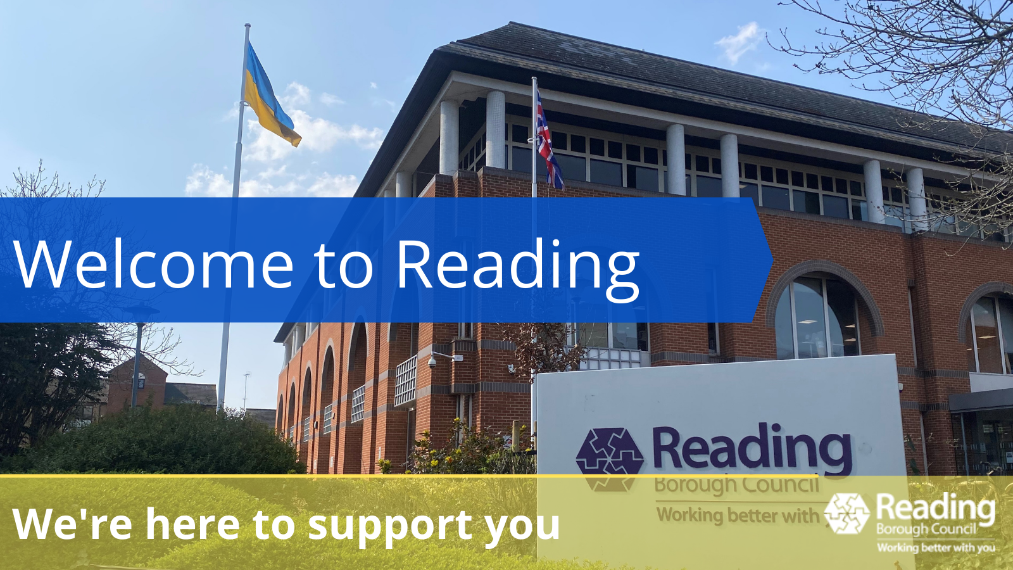
***Please use google translate to convert to your spoken language.***
Information from Reading Borough Council
Arriving in a foreign country has many challenges. The culture is different, the food is different, not to mention the differences in education, healthcare and other systems.
Reading Borough Council are committed to supporting you, your sponsor and your family, as well as keeping you safe.
As a Council we are working closely with the Reading Ukrainian Community Centre to ensure we help you in the best way.
We hope you find the attached Information for Ukrainian nationals arriving in the UK from the British Red Cross useful. The document contains information to help Ukrainian nationals who have recently arrived in the UK understand rights and find out about services and support you can access.
For emotional support please call the free British Red Cross support line: 0808 196 3651 (open between 10am - 6pm daily). If you need an interpreter, call and say, 'can I speak to an interpreter?'.
Below is local Reading information:
Reading Borough Council
Civic Offices, Bridge Street, Reading, RG1 2UL
0118 937 3787 (general enquiries)
0118 937 3737 (out-of-hours emergencies)
reading.gov.uk

Apply for Council Tax Support and/or Housing benefit:
Claiming Housing Benefit and /or Council Tax Support - Reading Borough Council
- 0118 937 3707

Schools:
To request a School place for your child:
admissions@brighterfuturesforchildren.org

Family Information Service/SEND Local Offer (including information on funded childcare option, support, activities and information on special educational needs and/or disabilities):
Reading Family Information Service | Reading Services Guide
fis@reading.gov.uk
0118 937 3777 (option 2)

Housing Advice:
0118 937 2165 (please leave a message and we will call you back)

If you are unable to access Reading Borough Council services online or over the telephone then please visit Customer Services at The Civic Offices, Bridge Street, Reading, RG1 2LU.
If you require an interpreter to access Reading Borough Council or Brighter Futures for Children services (above) then please contact the service and a telephone interpreter will be arranged.
Reading Borough Council are not able to provide interpreters for the services listed below. If you require an interpreter, please contact them directly.

Apply for Universal Credit:
Apply for Universal Credit - GOV.UK (www.gov.uk)
Register with a GP:
How to register with a GP surgery - NHS (www.nhs.uk)

How to find an NHS Dentist:
How to find an NHS dentist - NHS (www.nhs.uk)

How to get a National Insurance Number:
https://www.gov.uk/apply-national-insurance-number

Legal advice around visa and immigration:

UK visa support for Ukrainian nationals - GOV.UK (www.gov.uk)

Free UK immigration advice for people fleeing Ukraine https://advice-ukraine.co.uk/

Free advice and support for Ukrainian refugees https://ro-eehub.org.uk/

How to get an NHS number:
https://digital.nhs.uk/services/nhs-number
Transport around Reading:
Reading Buses (reading-buses.co.uk)

Reading Ukrainian Community Centre
21, Sidmouth Street, Reading, RG1 4QZ
info@rucc.org.uk
www.rucc.uk

Emergency Services
999 (for all emergencies)
111 (for advice on health concerns)
Work and Volunteering

Job Centre Plus
Adelphi House, Friar St, Reading, RG1 1HD
0845 604 3719

Reading Voluntary Action
3rd Central Library, Reading, RG1 3BQ
0118 937 2273

Local shops that sell Ukrainian food
These are just some of the shops that sell Ukrainian food in Reading:

EuroDeli
185 Oxford Road, Reading
0118 959 9912

Stokrotka Polish Food Shop
43 Whitley St. Reading, RG2 0EG
0118 304 3411

Pierożek Ethnic Food Shop
324 Oxford Rd, Reading, RG30 1AF
0162 877 3820

